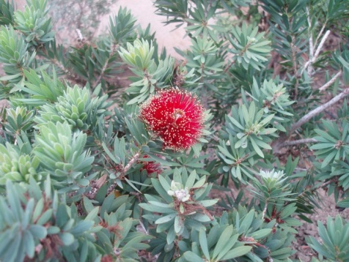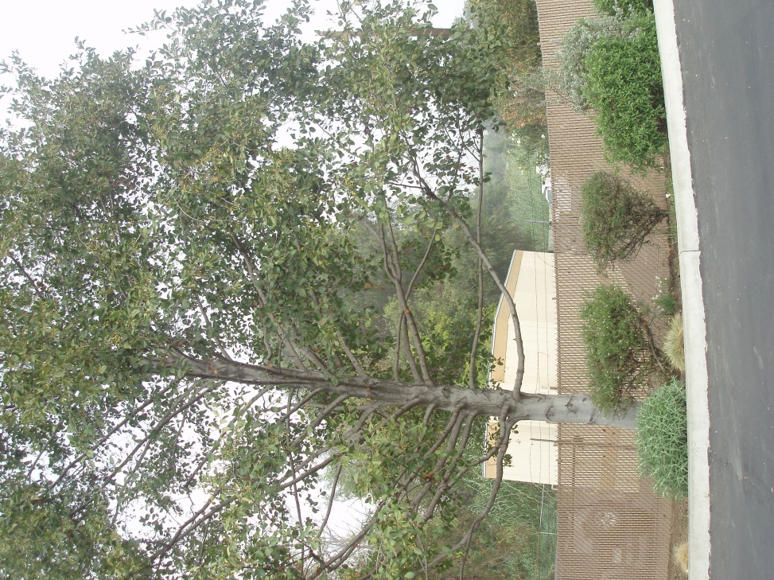 WHITE ALDER LA HABRA HEIGHTS COUNTY

WATER DISTRICT

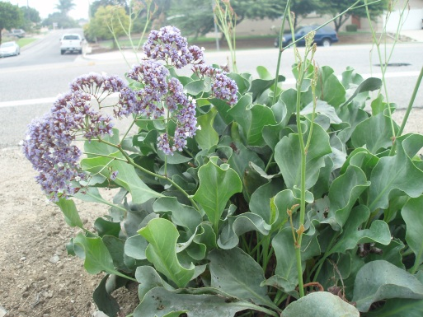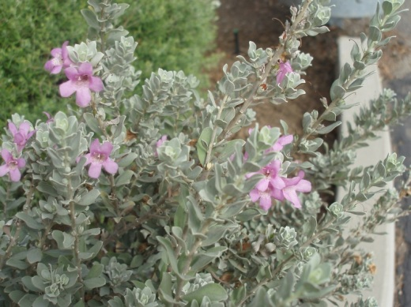 DEMONSTRATION GARDEN

LITTLE JOHN-BUSHES IN FRONT OF OFFICE

SEA LAVENDER- IN PLANTER NEXT TO HACIENDA ROAD

TEXAS RANGER

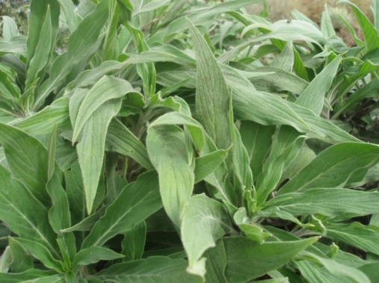

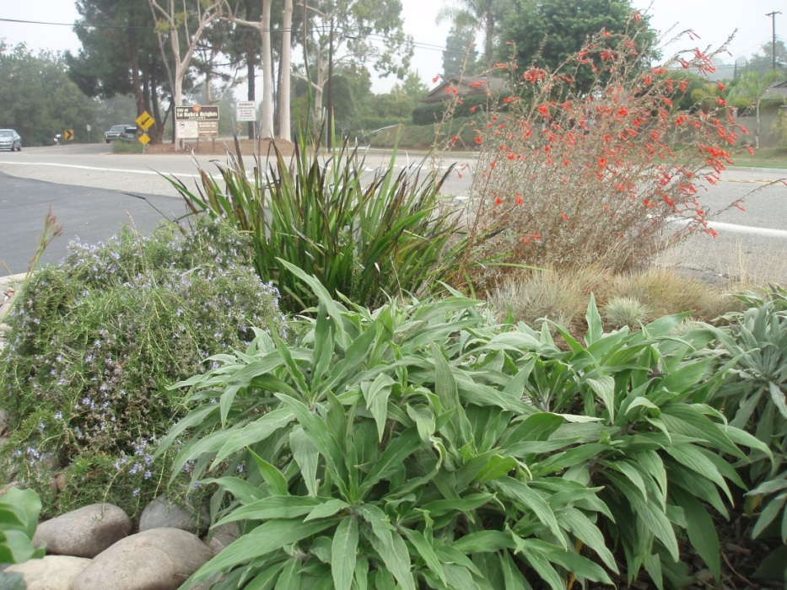

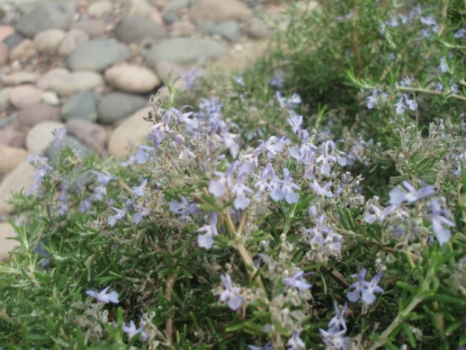

ECHIUM FASTUOSUM

ROSEMARY PROSTRATA

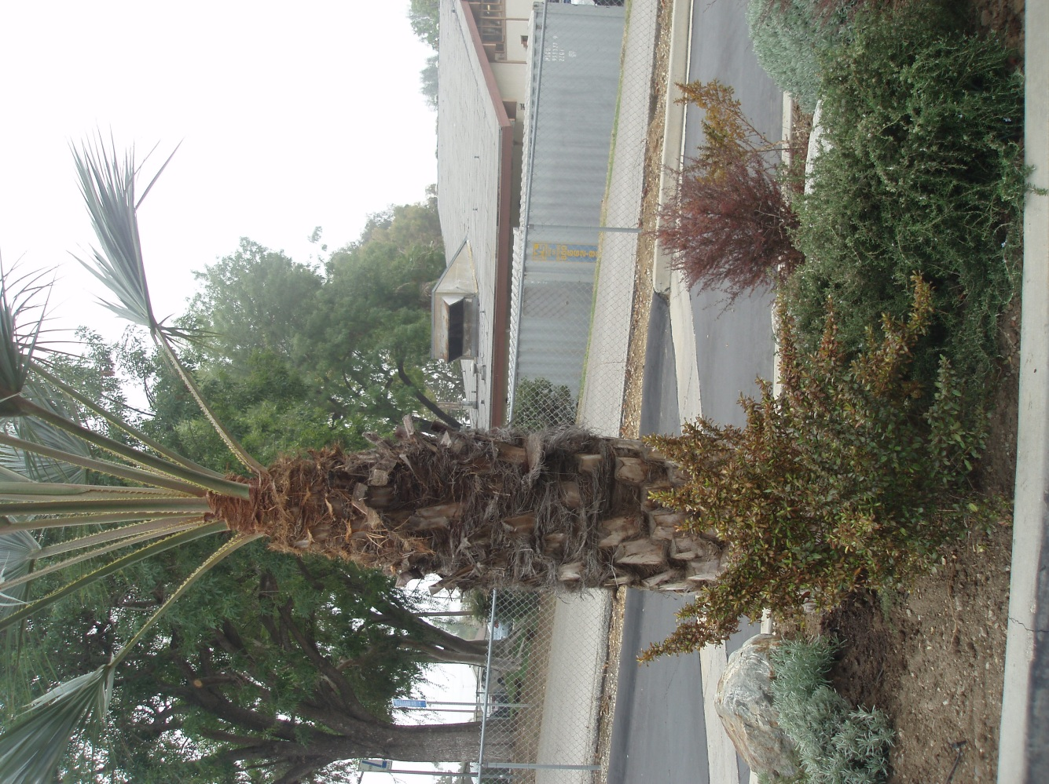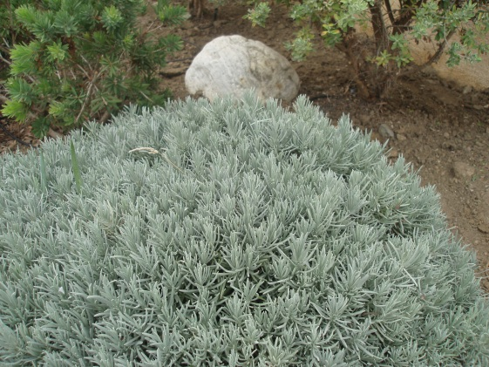 BLUE HESPER PALM 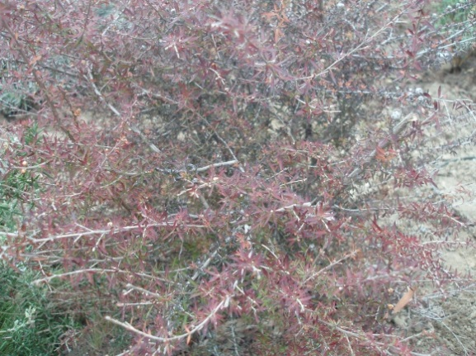

LA HABRA HEIGHTS COUNTY WATER DISTRICT DEMONSTRATION GARDEN

NEW ZEALAND TEA TREE

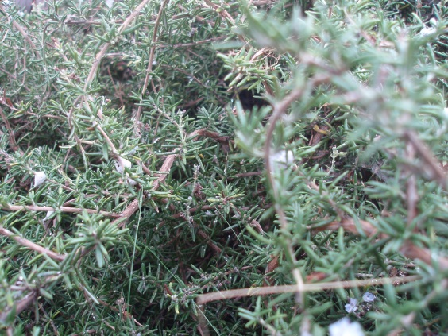

LAVENDER INTERMEDIA

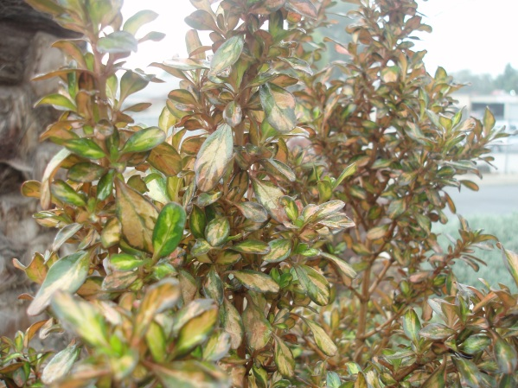

ROSEMARY PROSTRATA

COPROSMA REPENS-PINK SPLENDOUR

COPROSMA REPENS-PINK SPLENDOUR

LA HABRA HEIGHTS COUNTY WATER DISTRICT DEMO GARDEN

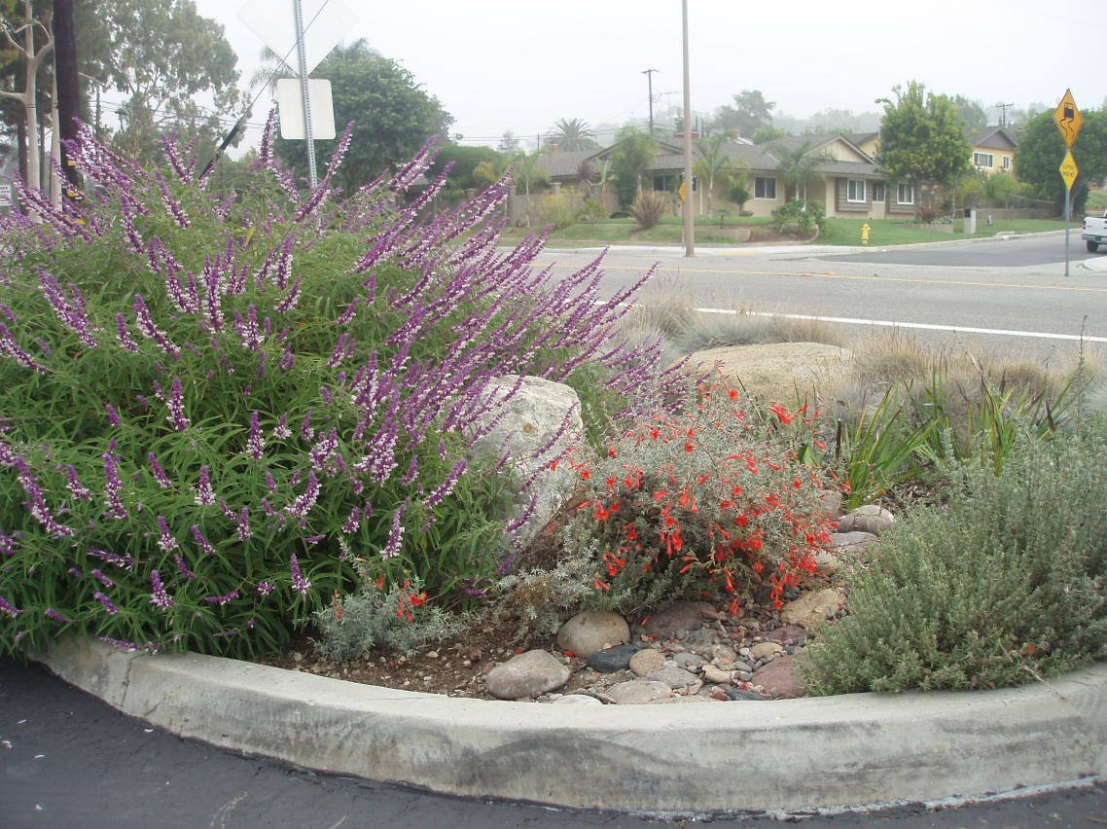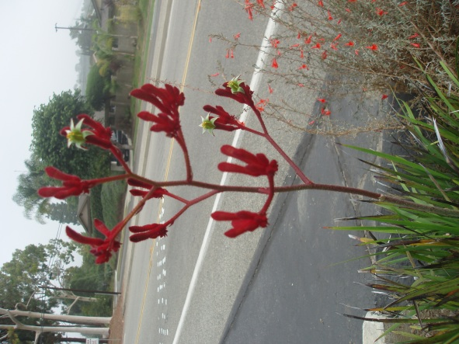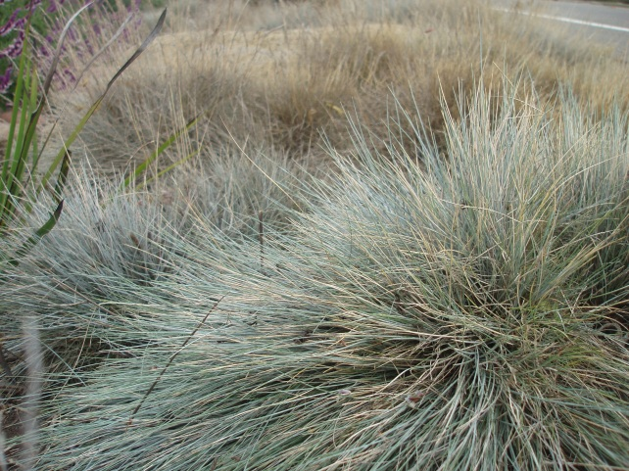

MEXICAN SAGE

BLUE FESCUE

KANGAROO PAWS

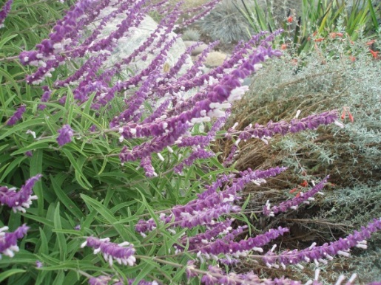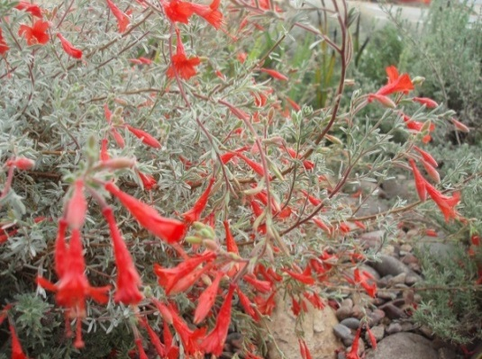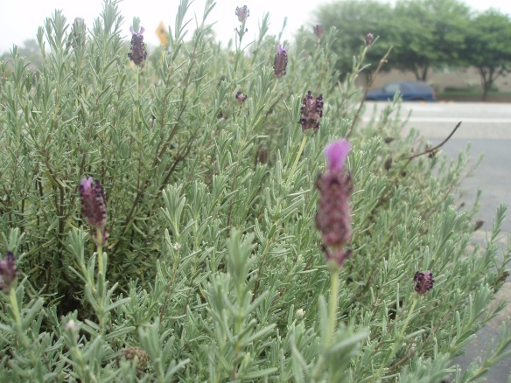

MEXICAN BUSH SAGE

CALIFORNIA FUSCIA

MEXICAN SAGE